Write a program that will generate 10 random numbers between -1 to 1 using 2 decimal places
Write a program that will print out the first n prime numbers where n is an input from the user. Check to make sure the value is positive.
Write a program that can shift a inputted string over by 3 ( A -> D, B -> E, … X-> A, Y-> B, Z-> C). This only works for letters
Try this problem too.
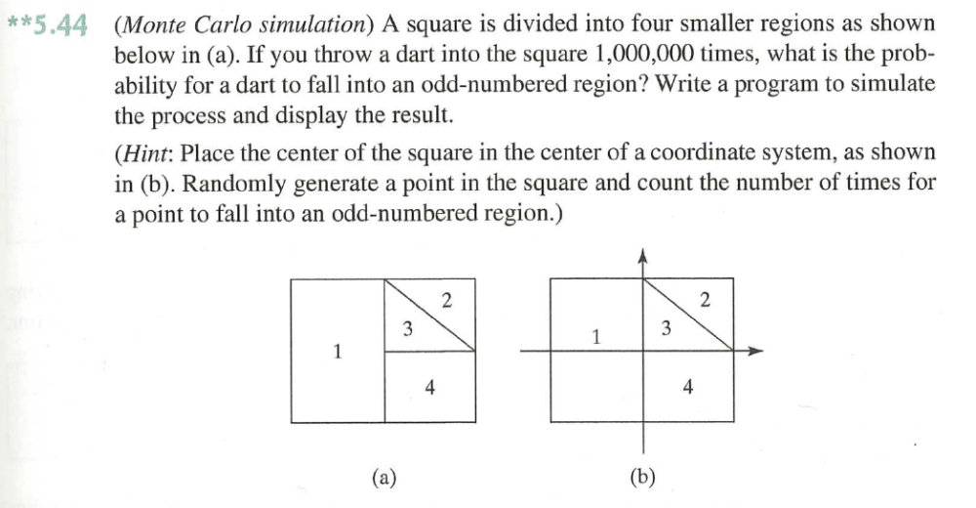

If you want more practice with c++ take some of the early labs and assignment from 1150 and implement them into c++.

